Sunday 16th April 2023

Unaffiliated
Fancy Dress Dressage


Amners Farm
Burghfield, Reading, RG30 3UE
With the kind permission of Wendy and Chris Webber

Entries Close: Wednesday 12th April 2023

NO ENTRIES ON THE DAY, NO TELEPHONE ENTRIES

Entries to: Show Secretary
Holmgarth, Betchworth Avenue
Earley, Reading Berks, RG6 7RJ

On line entries : admin@mortimer-rc.info

Telephone on the day : 07761 209044


Class 1: MRC Lead Rein Test 2017
Riders 3 - 8yrs old. Ponies under 12.2.
Combinations may not compete in Class 2. Lead-rein attached to the nose band.
Test can be found on MRC website.
Points will be awarded for costume and count to overall score


Class 2: Intro C (2016)
Section A - Riders 8 to12yrs
Section B – Riders 12 years and over
Points will be awarded for costume and count to overall score



Class 3: Prelim 12 (2005) Open
Points will be awarded for costume and count to overall score

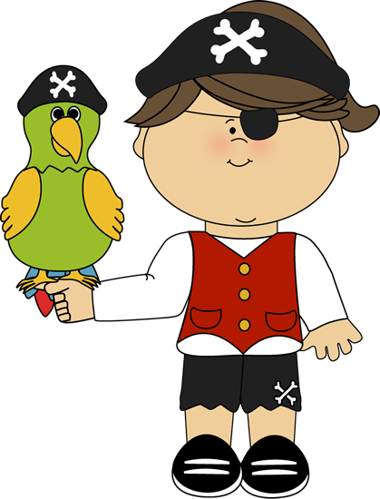
For start times please see the MRC website on Friday 14th April Alternatively, please include a SAE with your entry and your time will be sent to you.
All allocated times will be strictly adhered to.
Classes start at 10 am

Entry Fee: £10 MRC/Tadley Members
£15 Non-Members

ENTRY FORM

DRESSAGE SUNDAY 16th April 2023
Class | Rider Name | Horse/Pony Name | Rider Age | Entry Fee
 |  | Total Entry Fee

Name:...........................................................................................................

Address: ......................................................................................................

.....................................................................................................................

Contact Telephone Number: .......................................................................

MRC/Tadley Member ……… Rider age if under 18 …...

I enclose a cheque for £...... made payable to Mortimer Riding Club OR I have made a Bank Transfer to Nat West Bank, Sort Code 60-17-21 Account No 04245733. Please send completed form and cheque to:
Show Secretary, Holmgarth, Betchworth Avenue, Earley, Reading, Berks, RG6 7RJ OR on line to admin@mortimer-rc.info
I agree to abide by the rules and conditions of entry:
(Parent/Guardian signature if under 16)

Signed:......................................................... Date:...................................

RULES & CONDITIONS OF ENTRY
- It shall be deemed a condition of entry that Mortimer Riding Club, persons acting on their behalf, or their agents, or the landowners shall not be held responsible for any loss, injury, accident, damage or illness to horses, owners, riders or spectators or any other person whatsoever whether caused by their negligence, breach of contract or in any way whatsoever. The committee recommend that all riders have adequate personal, third party and horse insurance.
- Everyone mounted, whether a competitor or not MUST wear protective headgear at all times that includes a permanently fitted, non-detachable retaining harness secured to the shell at more than two points. Such headgear must be worn with the harness properly adjusted and fastened at all times. A riding hat complying with BSEN 1384 is the compulsory minimum required. However, British Riding Clubs recommend that the PAS015 standard or equivalent and must have BSI kite mark, be worn.
- First Aid will be provided via 999 service.
- Correct riding hat and footwear must be worn.
- The organisers reserve the right to cancel or alter the event or any of the published information.
- In the event of an objection the secretary’s decision is final.
- No refund of entry fees will be made except on receipt of a doctor’s or veterinary surgeon’s certificate.
- No horse or pony under 4 years of age may be ridden at the event.
- No stallions or dogs
- No cantering outside of warm up areas and arenas.
- Please observe care in the parking area and follow
instructions.
- Please leave the area tidy when you leave.
- No skipping out please and please clear up any
droppings in the car park.
- The Secretary may require to see Horse Passports, so please
have them available on the day
- No substitution permitted unless prior agreement of the Secretary
- No Lunging
- No warming up in the car park
- Photos may be taken for use in event Newsletter or MRC Facebook. Please advise if you do not wish your photo to be used.

